5b.ONE’S AND TWO’S COMPLEMENT

AIM:
To write and execute an assembly language program for performing One’s and Two’s Complement of given 8-bit numbers using 8085 Microprocessor.

APPARATUS:
8085 microprocessor kit 1
Power card 1
Keyboard 1

MASKING OF BITS

ALGORITHM:
Load the Data in A-register. Logically NOT the content of A.
Store the One’s complement in memory location. Increment the content of A.
Store the Two’s complement in memory location. Stop the program

Output:

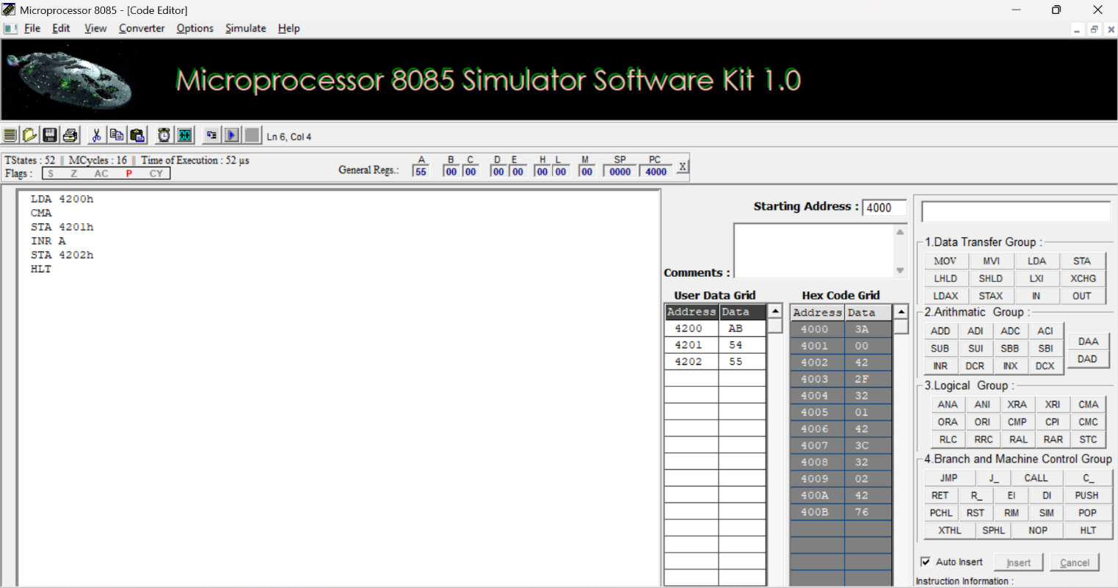
RESULT:
Thus, an assembly language program for performing One’s and Two’s Complement of bits were executed using 8085 kit.

